**Regulatory statement**

The Scottish Legal Complaints Commission

The Scottish Legal Complaints Commission (SLCC) is a regulatory authority with a range of statutory functions in relation to legal services. We have a vital role in in making legal services work for everyone and we deliver this by resolving complaints and raising standards in legal services and legal regulation. This helps to drive confidence in legal services, supporting access to justice.

Our powers and functions are set out in the Legal Profession and Legal Aid (Scotland) Act 2007, the Legal Services (Scotland) Act 2010 and the Regulation of Legal Services (Scotland) Act 2025.

Introduction

This statement outlines our understanding of the regulatory objectives and our initial thinking on how we will apply these to our work as we begin to implement the changes delivered by the Regulation of Legal Services (Scotland) Act 2025.

The purpose of this statement

The 2025 Act makes significant changes to the SLCC’s role, functions and processes.

The organisation is named as a ***regulatory authority*** and in delivering its individual statutory functions must, so far as practicable, exercise its regulatory functions in a manner which is compatible with the regulatory objectives (as set out in the 2025 Act), and it considers most appropriate to meet those objectives.

Changes to the detail of our functions were delivered through several discrete changes to existing legislation, amending or adding individual powers. Taken together these changes will mean a significant shift in our organisation’s powers and focus, and its place in the wider regulatory system. We recognise stakeholders will rightly expect clarity about how we will discharge our duties and what will guide our thinking. This applies to both existing, but amended, functions, such as our complaints processes, and to new powers such as operating a register for unregulated legal services.

This statement establishes high level principles for how we will go about our work, to aid stakeholders in understanding the approaches we will take and how these may evolve as implementation progresses. These principles will inform how we use our functions individually and collectively, and how we will work with others to play our part in delivering the regulatory objectives.

Our regulatory statement will sit alongside periodic three- or four-year strategies, and annual operating plans, which will set out specific work and priorities for any period. Each may inform the other. Our strategy will be developed in the light of our regulatory statement, but a strategy may involve commissioning work that, in turn, will inform the gradual evolution of our regulatory statement and approach.

We will also review this statement to reflect our practical experience of implementing the changes brought about by the 2025 Act, with further input from stakeholders.

The regulatory objectives

The Regulation of Legal Services (Scotland) Act 2025 sets out the objectives of regulating legal services and how they are to be applied; updating and extending those set out in the Legal Services (Scotland) Act 2010. These objectives are now applied to the whole regulatory system and to all of the regulatory authorities operating within it, including the SLCC.

In this statement we set out our understanding of the regulatory objectives and how they apply to our work, that is, how they will individually and collectively inform our overall approach as we develop and deliver all of our individual regulatory powers and duties.

1. To support the constitutional principles of the rule of law and the interests of justice

The rule of law is a vital element of a well-functioning and fair society. Definitions vary greatly, and we see ‘the interests of justice’ as part of that wide discussion. At its simplest, it can be seen as ‘no one being above the law’, that laws are clear, apply to everyone and are independently adjudicated. We believe it also includes, as some definitions do, access to justice.

**How we will apply this to our work**

* Consider our role as an independent adjudicator and regulator
* Ensure we have clear and understandable rules and guidance, and transparent, accessible and fair processes
* Ensure our regulation and judgements are consistently applied
* Set standards that are consistent with the rule of law and that aim to support others in upholding it
* Take proportionate action against those who breach rules or standards.

1. To protect and promote the interests of consumers and the wider public interest

The Act’s definition of consumer principles accords with those published by our independent Consumer Panel, which we already apply to our work, specifically that:

* a consumer should have access to a range of legal services that are affordable and suited to the consumer’s needs
* a consumer should receive sufficient information about the consumer’s rights and the services that are available
* a consumer should be treated fairly at all times
* a consumer should be able to access a means of redress when services are not of a suitable standard, and
* the views of consumers should be understood and taken into account.

We are also covered by the statutory Consumer Duty under the Consumer Scotland Act 2020. For us, any user of legal services falls within the definition of a consumer, whether or not they have actively sought or paid for the service provided (for example, those being provided with criminal legal representation funded by legal aid).

The public interest is often defined as relating to the public good, or what is in the best interests of society as a whole. Matters of public interest are likely to have a widespread impact. They may directly affect large numbers of people, or have a wider societal impact (for example, on public confidence).

The public interest can conflict with any individual consumer’s interests, and we must manage that conflict in our work.

**How we will apply this to our work**

* Consider how we deliver all of our functions in the public interest
* Provide information and advice to consumers on their right to complain and seek redress when services are not of a suitable standard
* Treat consumers fairly in our individual adjudications
* Have regard to the impact of our strategic decisions on consumers, with the aim of reducing harm
* Support and promote the consumer voice so that the views of consumers are understood and taken into account across the regulatory system, including in our own work
* Support the independent Consumer Panel to deliver its functions.

1. To promote access to justice

In a fair society all citizens should have access to the advice and representation they need to access justice. That means balancing standards and protection with affordability and accessibility. It requires regulation that is proportionate and informed by risk (including the risk of restricting access).

Part of promoting access to justice is promoting an understanding of the full market. It will include ensuring our regulatory approaches do not unduly hinder access and, where possible, positively contribute to increasing access to justice.

**How we will apply this to our work**

* Discharge our core functions to support confidence in legal services so that people access the help they need
* Provide clear information for consumers on using legal services and their right to complain and seek redress when services are not of a suitable standard
* Through our work, identify trends in access or in the market that might inhibit or promote access to justice
* Use our new powers relating to the unregulated legal services market to build confidence in a wide range of legal services.

1. To promote an independent, strong and diverse legal profession

The legal profession must be able to act without fear or favour, and independence from government is a vital element of this principle. The profession must also balance their responsibilities to act in the best interests of a client with responsibilities as an officer of the court and to the wider public interest. Likewise, regulation needs to maintain appropriate independence from those it regulates.

‘Strong’ suggests a profession which is healthy in terms of the numbers needed to meet the needs of citizens, understands and is confident in its roles and responsibilities, and has new entrants refreshing supply.

‘Diverse’ may be interpreted in its broadest sense, in terms of protected characteristics, but also other forms of social, economic, educational, experiential and geographic diversity and intersectionality. This also includes diversity of views, thinking and approaches. This aids access to justice as some people may be more likely to seek legal help from those they trust or identify with.

This objective implies a responsibility beyond the existing legal profession to include those joining the profession and those who become part of the wider sector as the diversity of legal providers grows. More broadly, a regulatory authority must encourage equal opportunities.

**How we will apply this to our work**

* Promote actions that support the independence, strength and diversity of the legal profession
* Promote initiatives that support entry and progression for people from under-represented or disadvantaged groups
* Ensure our own operational independence from government, the regulated sector, and other interests, and transparency about our accountabilities
* Use our understanding of the profile of the sector to assess the impact of our decisions, policies and approaches on equalities.

1. To promote quality, innovation and competition in the provision of legal services

We believe that good quality legal services should be in line with broader social objectives but also meet the needs of the individual users of the service. The service provided should be of a standard that matches any marketing promises. Ongoing learning should review, refine and improve the quality of services.

It is in the interests of the public and profession that new services can be tested and developed, and we understand our role as encouraging and promoting innovation and removing unnecessary regulatory barriers.

Competition can also help a market grow, innovate, and provide the services most needed by individuals in ways that suit them. The wide definition of legal services means that this objective relates to encouraging open competition across the whole legal services market, while providing proportionate regulation to protect consumers.

Inherent in both innovation and competition is the idea that some models may not succeed, and this risk must be balanced with protections for affected consumers.

**How we will apply this to our work**

* Tackle instances of inadequate quality through individual complaints handling and redress
* Identify trends in quality to inform our guidance, advice, training and standard setting
* Develop approaches that support ongoing quality improvement in our work, and support this across the sector
* Assist with consumer input into definitions of quality, and acceptable tolerances around competition and innovation, through our independent Consumer Panel
* Ensure our polices and approaches do not unduly or unintentionally limit innovation or competition
* Understand and support innovative approaches to providing legal services, including different business models or new technologies, while considering any impact on consumer protection or potential detriment.

1. To promote effective communication between regulators and legal services providers

For the regulatory system and market to work well, effective communication is required between all the different actors. This is likely to include engagement in the design, delivery and review of policy and approaches, transparency about activity and performance, a willingness to listen and respect views, and consistent approaches and messaging, where appropriate.

Effective communication is vital to ensure that regulators develop a deep understanding of the needs, views and realities of legal services providers, to inform regulatory approaches, and that providers can in turn understand and inform the regulations that govern their work.

**How we will apply this to our work**

* Establish arrangements for effective dialogue with the Regulatory Authorities and look for opportunities to work together to drive improvement
* Work with other bodies involved in the complaints system to provide seamless process information
* Seek opportunities for joint messaging or communications for legal services providers
* Establish arrangements for effective dialogue with legal services providers, directly and through their professional bodies and other representative groups and associations.

1. To promote effective communication between regulators and bodies that represent the interests of consumers

It is also vital that regulators have effective communication with bodies representing the interests of consumers. This helps to ensure that the views of consumers are understood and taken into account across the regulatory system and their needs and experiences inform regulatory activity and approaches.

**How we will apply this to our work**

* Continue to support the independent Consumer Panel in its work
* Establish arrangements for effective dialogue with consumers, through the Consumer Panel, other representative groups and associations and through research and consultation with individual consumers
* Seek opportunities for joint messaging or communications for consumers.

1. To use and promote best practice in relation to assessing and improving the quality of regulation and compliance with applicable legislation and rules

This sets a clear focus on using evidence to inform ongoing improvement, in our own work and where we oversee the work of other regulators.

**How we will apply this to our work**

* Seek opportunities to learn from regulatory practice in other sectors and jurisdictions
* Set objectives each year in our operating plan to continually improve the quality of our approach to regulation and complaints handling
* Use evaluation and reflection to help embed learning and continuous improvement in all we do
* Draw on and promote best regulatory practice in the guidance we provide, the recommendations we make and any standards we set
* Understand where legislation provides us with opportunities to improve our approach.

1. To adhere to the regulatory principles

The regulatory principles are set out in the Act and broadly mirror the Better Regulation principles that regulation should be transparent, accountable, proportionate, consistent and targeted. We also believe regulation should be agile in responding to changes in the external environment, including evolving technologies, and changing consumer and sector needs.

In addition, the Act requires that functions should be exercised in a way that contributes to achieving sustainable economic growth (except where this would be inconsistent with other functions). We would consider economic growth in its widest sense, looking both at how regulation aids economic growth across the legal services market and how legal services support growth in the economy more generally.

**How we will apply this to our work**

* Use this statement to set out an overarching approach to delivering our duties and functions that is consistent with the regulatory principles
* Use all of the appropriate tools and powers at our disposal to achieve the regulatory objectives, to deliver our functions and to make legal services work for everyone
* Be **transparent** by:
  + making our approach clear, simple, open and user-friendly
  + consulting as proposals are developed
  + communicating well and clarifying our expectations
  + communicating openly about our own work, governance and accountabilities
  + giving clear explanations when we believe escalation is required
* Be **accountable** by:
  + laying and publishing our annual budget and accounts in parliament
  + consulting with stakeholders on our approach and our plans
  + justifying our decisions
* Act **proportionately** by:
  + applying solutions proportionate to any perceived problem or risk, taking due account of the cost of compliance
  + escalating our approach and taking formal action only where that is warranted in response to significant risks or serious and sustained failings, and only where informal engagement, support and influence have failed to secure compliance
* Be **consistent** in:
  + applying our regulations and decisions
* Be **targeted** by:
  + focusing on key risks to the public interest, or those likely to lead to consumer harm, detriment or loss of confidence in legal services.

In considering regulatory action we will:

1. Identify key risks and solutions
2. Engage in open dialogue to explain our aims and understand any barriers to implementation or alternative approaches
3. Set out our expectations clearly and encourage and support others to act
4. Monitor and seek assurance on compliance
5. Escalate any concerns and explore opportunities for agreement
6. Take formal action only if required
7. To promote and maintain adherence to the professional principles

The professional principles are set out in the Act, and responsibility for adherence rests with relevant regulated individuals. The principles are that a person providing legal services should support the proper administration of justice, act with independence (in the interests of justice), with integrity and in the best interests of the person’s clients (and keep clients’ affairs confidential), maintain good standards of work, comply with duties owed to the court, meet obligations under any relevant professional rules and act in conformity with professional ethics.

Consumer confidence in the principles is likely to be a key element in a consumer’s decision to use a regulated professional.

**How we will apply this to our work**

* Promote and maintain adherence through our complaints handling
* Ensure any guidance we provide, recommendations we make or standards we set are in line with the professional principles.

Our approach

Having reflected on the regulatory objectives and their application to our work we have started to consider how we will deliver our new role. This approach will be consistent across how we deliver our day-to-day operational role, including our complaints functions, as well as our new or expanded powers.

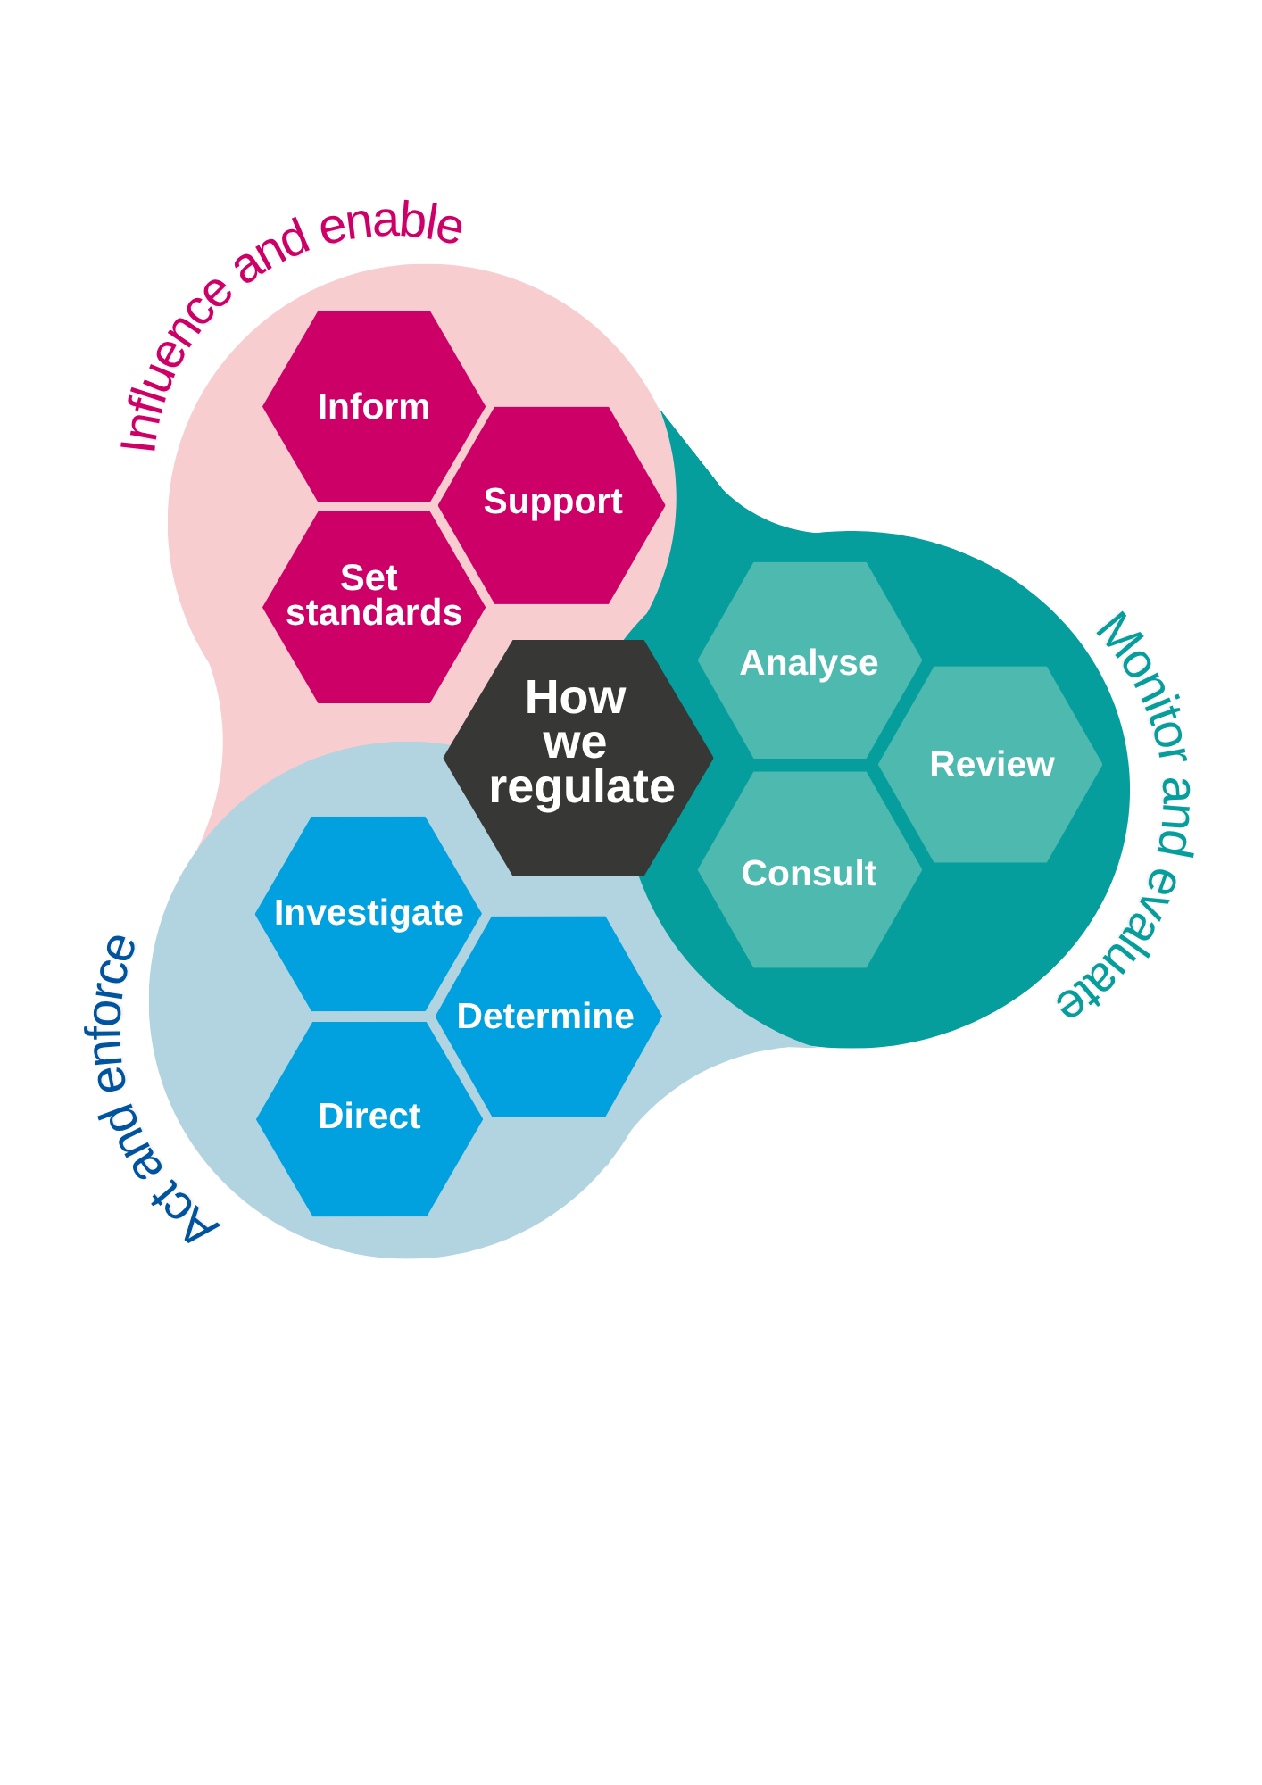

We will:

**Apply overarching values and drivers**

* Act in the public interest
* Listen, learn and collaborate to have the greatest impact
* Look holistically at how we can use our powers to protect consumers from harm and detriment
* Wherever possible, take action through influence, engagement and formative approaches
* Focus on improvement in our work and use our powers to support improvement across the regulatory and legal services sector

**Influence and enable** (inform, support, set standards)

* Empower consumers through information and support
* Promote preventative approaches and support providers to resolve complaints
* Share data and insight to support improvement
* Be clear and transparent about what we’re seeking to achieve and what we expect from others

**Monitor and evaluate** (analyse, review, consult)

* Assess the costs, benefits, risks and impact of any new measure or proposal
* Seek assurance on compliance and be open about and any progress made
* Be agile in our approach, responsive to changes in the external environment, consumer needs or new opportunities for improvement
* Evaluate our approach, drawing on feedback from users and stakeholders

**Act and enforce** (investigate, determine, direct)

* Make fair and impartial decisions on complaints
* Take proportionate and targeted action based on our assessment of key risks to public protection, natural justice and public confidence
* Use our statutory powers, where necessary, to take action or to compel others to act.